Transcription using Transana
Posted on 9 September, 2016 by Lydia Wysocki
Here’s an update on work transcribing the video recordings of sessions for Enquiry 1 (Great Fire of Newcastle and Gateshead) and Enq 2 (Ancient Mesopotamia).
I’m using Transana software https://www.transana.com/. This is the first time I’ve used it – it was a lot to get my head around, and now it’s proving very useful. Here’s a screenshot:
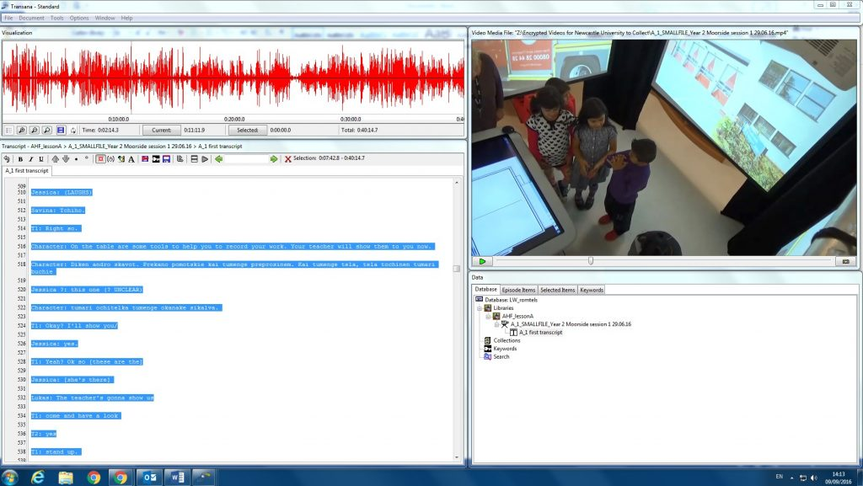
I transcribe (bottom left) what is in the video (top right), then use timecodes to link the transcript to the video. These timecodes mean that as I use the waveform diagram (top left) to navigate through the video, the transcript keeps pace with the video: easier than trying to fast forward through a video player and a Word document separately! The file diagram (bottom right) shows where the videos and transcripts are stored, so separate files can be treated as part of the same episode (part 1a, part 1b, 1c…). This is useful as we’re following children’s progress as they complete an Enquiry over 3 or more timetabled sessions, so we can be confident that the videos and transcripts for each group are kept together.
As agreed at the November 2015 Newcastle project meeting, the transcription is done using Discourse Analysis (DA) conventions. Specific conventions are:
- [square brackets] for simultaneous speech
- underlining to show the speaker’s emphasis/stress on utterances
- ? question mark to show rising intonation
- (.) brief pauses, with more dots to show a longer pause
- (NOTES IN CAPITALS IN BRACKETS) to show comments about the discourse but not part of it
- italics to show home language(s) spoken in class, for example Roma spoken in a English/French/Romanian/Finnish class
- {curly brackets} to show English translation of home language spoken in class.
The videos have captured a huge amount of data. Some utterances are unclear, either because speakers are whispering or because of louder sounds (including characters and sound effects from the Enquiries). Hopefully the second videocamera and dictaphone we added for the later recordings will help, as will the snippets of audio recorded data on the digital tabletop microphone tool.
It’s already clear that children are using both English and their home language(s). I’ve spotted a few examples where children mix between English and home language(s) in the same utterance, and of course there may be examples of translanguaged versions of Slovak and East Slovak Roma. At this stage I’m transcribing as much as I can in English, and a phonetic version of the home language(s). Even though I don’t understand these home language(s), hopefully this phonetic version will help when we work with translators and parents to understand what the children are saying in their home language(s)
Here’s an example of a transcript using the DA conventions listed above (we don’t yet have the home language(s) translated into English):
01 T1: That’s great. Does S want to [choose a picture]
02 T2: [So that’s the picture book], a picture book [these stones]
03 J: [Is that what it is] Nashine das datoy twoj.
{English translation will go here}
04 T1: (TO T2) Can I ask you to step back
05 J: Tost toyatwo tulia beck. Na ten mushi tas tun ebar tu etar na kiesko. Na tuta line.
{English translation will go here}
06 S: Tu?
{English translation will go here}
07 J: Tush, tutaj. Kush taa.
{English translation will go here}
08 T1: (TO T2) It’s good isn’t it.
09 T2: Yeah.
Next steps are to keep going with transcription for the other videos, work with translators and parents to understand what children are saying, and to then move on to analysis. We’ve also set up a secure way to share video files, so that you’ll be able to (1) watch these videos and (2) make videos from your context available to share with other partners. I’ll share more information on this soon.
This entry was posted in General project updates, WG2 dual language/translanguaging and tagged DA, discourse analysis, transana, transcription, translanguaging, video by Lydia Wysocki. Bookmark the permalink.

